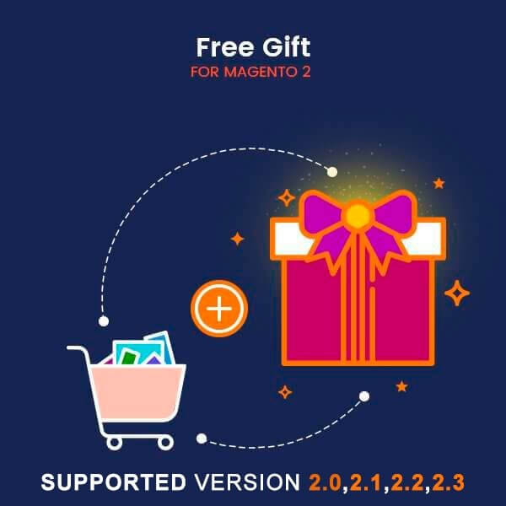

Free Gift-Magento 2

USER MANUAL

Supported Version: 2.0, 2.1, 2.2, 2.3

Table Of Contents

Preface ......................................……………………………………......3

Installation...................................………………………………………..4

Option 1: Magento 2 install extension using COMMAND LINE .........…………..…..4
Option 2: Magento 2 install extension manually ………………………………….......5

Backend Example ………………………………………………………...……...6

Extension configuration………………………………………………………...6

Frontend Example………………………………………………………………….10

Product page………………………………………………………………………...10

Cart page……………………………………………………………………………...11

Preface:

- Free Gift with Purchase is a perfect extension for the store owners who wants to
add some free gift in cart automatically.

- Using this Magento promotion extension, you can run some offers with free
gifts items at your store.

- For example, customers will get promotional gifts when they buy certain
products.

- Auto-add free gifts to cart when customers add main products to cart.

- Show all Free Gift information on product pages.

- admin can easily add catalog price rule for that & set maximum quantity of
each gifted product.

- Compatible with Most of the Browser.

- Easily Enable/Disable form admin.

- Easy to Add/Delete/Edit/Update free gift product from admin side.

- Make extension compatible with Api and GraphQL in magento version above 2.3 .

Installation:

There are two ways of installing extension in magento2.

1) Using COMMAND LINE.
2) Manually install extension.

Option 1: Magento 2 install extension using COMMAND LINE (Recommended).

Follow below steps to install extension from the command line.

Step 1: Download the extension and unzip it.

Step 2: Upload it to code directory in your magento installation’s app directory.
If code directory does not exists then create.

Step 3: Disable the cache under System → Cache Management.

Step 4: Enter the following at the command line:
php bin/magento setup:upgrade
php bin/magento setup:static-content:deploy

Step 5: Once you complete above steps log out and log in back to the admin
panel and switch to Stores → Configuration → Mageants → Freeproduct.
The module will be displayed in the admin panel.

Option 2: Magento 2 install extension manually.

Step 1: Download the extension and unzip it.

Step 2: Upload it to code directory in your magento installation’s app directory.
If code directory does not exists then create.

Step 3: Disable the cache under System → Cache Management Edit
app/etc/config.php file and add one line code: ‘Mageants_Freegift’ → 1

Step 4: Disable the cache under System → Cache Management

Step 5: Once you complete above steps log out and log in back to the
admin panel and switch to Stores → Configuration → Mageants →
Freeproduct, the module will be displayed in the admin panel.

Backend Example:

After Installation of Extension login to magento admin panel to set
configuration of the extension.

Extension Configuration:

You can find configuration at Stores -> Configuration -> Mageants -> Free
product.

As per below screenshots you can set all the settings here.

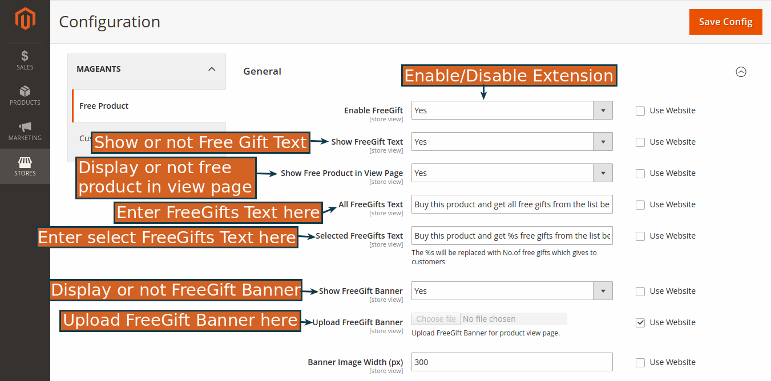

Create catalog price rule as per requirement.

Set all the fields as per below screen shot.

- Use particular coupon code and receive free gift.

- Based on subtotal rules receive free gift.

- In Action tab need to enter free gift SKU.

- There are two way to give free gift.

1) All of the sku – Means customer directly receive all free sku product.

2) Customer select sku – Here, you give option to customer, choose
product as per need.

Frontend Example:

Here Customers can see list of all the free products which is added frombackend.

Product page:- Customer choose product as per need.

Cart page:

→ Here, you can see customer purchase 1product and receive
2free product as a gift. (Free product also display with Free
product tag).

Thank you!
if you have any questions or feature suggestions, please contact us at: https://www.mageants.com/contact

Your feedback is absolutely welcome!

